

Sri Lanka Institute of Information

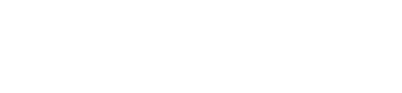

Technology

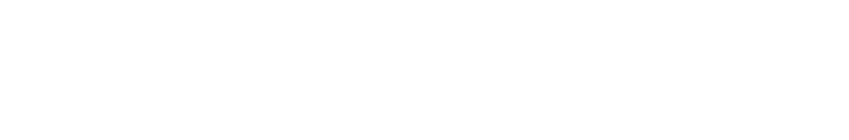

**Database Management Systems**

**for**

**Securit**

**y**

**-**

**IE2024**

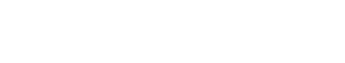

Lab Submission 01

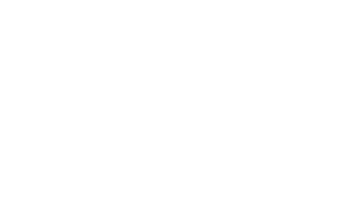

**IT22151056**

**De Silva K.R.K.D**



Year 2, Semester 1





Activity 01 1) 8 entities

* Bank
* Branch
* Account
* Customer
* Transaction
* Account type
* Current account
* Saving account

1. No
   * 1. Branch

* + 1. Weak entities depend on strong entities and they cannot exist without strong entities.

1. one to many

Many to many

* 1. Yes,

Account type – superclass

Saving account type, current account type – subclasses

a) Disjoint and covering - Account type may be saving or current.

* 1. No

4)

|  |  |  |
| --- | --- | --- |
| **Entity** | **Key** | **Attributes** |
| 1. Bank | Code, Name | Code, name, registration number |
| 2. Branch | Branch number | Branch number, branch name, address |
| 3. Account | Account number | Account number, balance |
| 4. Transaction | Transaction id | transaction id, date and time of transaction, amount, and responsible party or application for the transaction |
| 5. Customer | NIC, Customer number | customer number, NIC number, name, address, phone, and PIN. |
| 6. Account type | Account code | name, a code and a description |

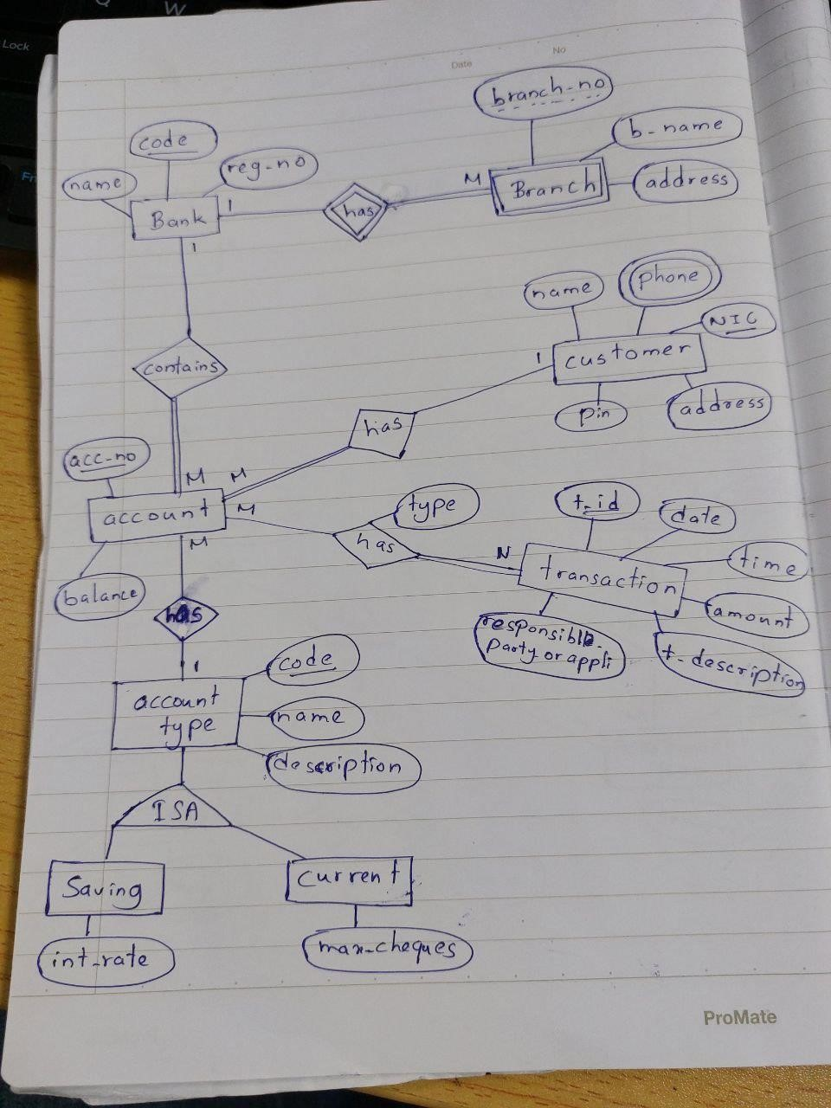

# Activity 02

1. 6 entities
   * Campus
   * Program
   * Batch
   * Academic semester
   * Semester
   * Student

1. No
   * 1. Semester

* + 1. Weak entities depend on strong entities and they cannot exist without strong entities.

1. One to many

Many to many

* 1. No

* 1. Batch, Academic Semester

a) Many to many

One to many

4)

|  |  |  |
| --- | --- | --- |
| **Entity** | **Key** | **Attributes** |
| 1. Campus | Code , Name | code, name and address |
| 2. Program | Code | Code , Name, description and specialization |
| 3. Batch | Id | Id, Group number,  maximum number of  student, section |
| 4. Academic year | Academic Semester, Academic year | Academic Semester, Academic year |
| 5. Student | Registration number | Registration number, name, address, phone |

